SEFLab Admin Manual

# Introduction

Within this manual the SEFLab employees will be able to find information regarding configuration of the automated testing software developed by SEFLab team 05. The manual will contain guides for both back- and frontend software. Also you will find a section explaining the required third party software.

Table of Contents

Introduction 1

Software requirements 2

Webserver Software 2

MySQL database 2

Virtual box 3

Operating system and Java 3

Changing the software’s properties 4

Backend Software 4

Website 5

# Software requirements

This chapter will zoom in on all the required software that has to be installed and properly configured for the software, developed by SEFLab 05, to work properly. Keep in mind that the software was developed to be able to run on two separate systems to keep the readings as accurate as possible.  
The software that has to be installed and configured are as follows:

* Webserver software, with PHP support
* MySQL Database 15.6.+, with Database management software
* Virtual Box
* Windows based platform, Windows 7 or higher (for measurement computer)
* Java 1.7+

## Webserver Software

After careful consideration we have selected the Apache 2 webserver software to function as webserver software. The installer and managing software that we will be using is XAMPP. Of course you can utilize other software than XAMPP, WAMPP for example, but we will write this guide for the XAMPP software.

If you are using XAMPP to install and manage the apache webservice follow the steps provided by the installer. XAMPP can be downloaded from the official website: <https://www.apachefriends.org/index.html>.   
NOTE: the MySQL database and PhpMyAdmin software can also be installed via the XAMPP installer if you have not done so yet.

After having installed and started the Apache webserver you will need to edit the php.ini file located in the php folder located in the root of the installation folder. If the server cannot be started because of a network port error check if no other programs, such as Skype, is running on the same port. Open the file using the text editor of your choice, such as notepad on a windows platform. You will need to edit the following lines as such:

* upload_max_filesize=128M -> upload_max_filesize=0
* default_socket_timeout=60 -> default_socket_timeout=6000
* post_max_size=128M -> post_max_size=0
* max_input_time=60 -> max_input_time=6000

After altering the values of the variables restart the apache server.

NOTE: Keep in mind that with different versions the default values of the variables may vary.

## MySQL database

Install the MySQL database software through the official oracle website or through the XAMPP installation process. You will also need a MySQL database managed program such as MySQL Workbench or PhpMyAdmin, the latter of which can also be installed during the XAMPP installation. Make sure you use at least MySQL 15.6.+ server software.

Either of the installations will present you with the opportunity to create a new database user with certain privileges and the option for choosing a root user password. We strongly advise against the usage of the root user account for usage within the application for security purposes. As such we advise you create a new user with only CRUD(Create Read Update Delete) permissions.

We recommend you install a piece of MySQL management software such as PhpMyAdmin or MySQL workbench and connect this to the created MySQL database service using the root account or either an account that has the privileges to create new databases.

After having completed the previous steps go on to creating the database. Added to the manual will be a SQL create script called *‘seflab.sql’*. Either copy all the content of the script to your MySQL query prompt or execute the script via the application directly.

## Virtual box

Download the virtual box software from the official Oracle website. Follow the installation process and configure the application accordingly. The software can be downloaded from virtualbox.org.

## Operating system and Java

For the webserver you can use whichever piece of operating software you wish. On the webserver you will be required to be able to execute Java software, as such the Java software platform is required to be installed on the server.

For the measuring system a Windows Platform of at least Windows 7 is required. This computer will also require the Java software platform to be installed.

# Changing the software’s properties

In this chapter we will explain how to change the software’s variables. To do so you will need the following tools:

* a text editor

## Backend Software

Configuring the Server and Measure systems properties. Thanks to the usage of configuration files it is very easy to change settings for the systems.

To change the properties for the programs create two files in the C:\SEFLab directory. Call the first one serverConfig.properties and the second measureSystem.properties. (of course in this example we are using one pc to test both pieces of software, if you are using two systems create one appropriate file for each system.

An example of the serverConfig.properties  
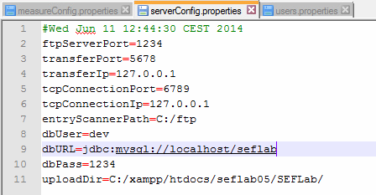

* ftpServerPort -> the port the FtpServer activity will run on.
* transferPort -> the port the FtpClient will transmit its data to.
* transferIp -> the IPv4 address where the FtpClient will transmit its data to.
* tcpConnectionPort -> the TCP port the server will send it’s requests to.
* tcpConnectionIp -> the IPv4 address which the server will send its requests to.
* dbUser -> the database’s user
* dbPass -> the password which is used for the database user
* dbURL -> the database URL referring to the database’s location
* uploadDir -> Path where the entryScanner will look for the VM’s and Scripts

An example of the measureConfig.properties  
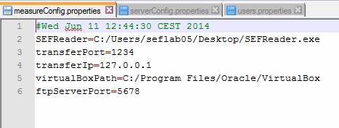

* SEFReader -> Path where the SEFReader.exe is located
* virtualBoxPath -> Path referring to the VirtualBox Software

All these variables are needed to make sure the applications will function properly.

## Website

To alter the database connection you will need to alter the database.php file located on the webserver in the config folder using a text editor.

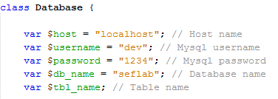

* The host variable is the ip address pointing towards the machine hosting your database.
* Username refers to the user you want to enable to access and alter the information in your database.
* Password is the password used for the user defined within username.
* Db_name is the name of the database to be used.

To store the uploaded files you will need to create a folder named “files” in the root of your websites directory.

## 